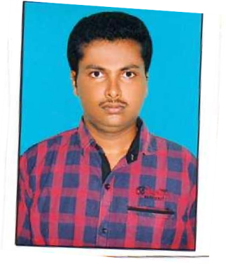**CURRICULUMVITAE**

**N.Balakrishnachaitanya H.NO:3-88,chandrupatla,**

**Vissannapeta(v)&(Md), E-mail:**[nbk.chaitu03@gmail.com](mailto:nbk.chaitu03@gmail.com)

**KrishnaDist. Mobile**:9502193639

# OBJECTIVE:

To work with areputed institution as an Assistantprofessor, that will provide me a good platform to utilize my teaching & administration skills and will help me to grow my career.

# EDUCATIONALQUALIFICATIONS:

|  |  |  |  |  |
| --- | --- | --- | --- | --- |
| **COURSE** | **Yearof**  **passing** | **Board/University** | **Nameof Institution** | **Percentage** |
| M.Tech (EMBEDDED SYSTEMS &VLSI) | 2019 | JNTU-K | SreeVahiniInstituteof Science&Technology | 72% |
| B.Tech(ECE) | 2014 | JNTU-K | Prasad V Potluri InstituteofScience  &Technology | 56.86% |
| Intermediate (M.P.C) | 2010 | Boardof Intermediate | DKNPJuniorCollege | 75.7% |
| S.S.C | 2008 | Boardof Secondary  Education | SSP School | 62% |

## AcademicExperience:

* Workedas an AssistantProfessorinDJRCollegeofengineering&Technology,Velpur from DEC – 2019 to Jan-2024.
* Working as anAssistantProfessorinSRGECCollege,from8thFeb –2024 toTill date.

## ProfessionalQualifications:

* + Posses about five years experience in the field of education(bothteaching and administration)
  + Thorough understanding of the subject with ability to convey the same to the students
  + Good communication andcomprehension abilities
  + Posses knowledge about theinternaladministrativetasksthatareperformedwithin institutions

## KeyResponsibilitiesHandled:

* + Participateinstudentrecruitment,registration,andplacementactivities.
  + Maintained collegewebsite &networking.
  + Acting as advisers to studentorganizations.
  + Participating incampus and communityevents.
  + Providingguidancetothestudentsfordevelopingtheircareeraswellasmaking.them familiar with different career opportunities.

Helping the students for completing their project works.

# SKILLS:

* Motivator.
* Good listening and speakingskills.
* Good Explanation skills.
* Can easily interact with students.
* Disciplined.
* Always update myself.
* Problem solving skill

## Workshops&conference attended:

* I Participated in work shop of IOT integeration with AIMLopportunities and challenges
* I Participated in online workshop of machine learning applications in mechanical engineering

# .



# PERSONALPROFILE:

**Name** :N.BalaKrishna Chaitanya

**Father’s Name** :Suribabu **Gender** :Male **Marital Status** :Married

**LanguagesKnown**:English,Telugu,Hindi

# DECLARATION:

I here by declare that the above-mentioned information is correct upto my knowledge and I bear the responsibility for the correctness of the above-mentioned particulars.

**Place**:

**Date:**

**(N.Balakrishnachaitanya)**